2D Depth and Slope
Depth and Slope mode lets you use slopes, sections, and offsets as required, to define your target grade.
To generate guidance information, the system measures the cutting edge's position relative to a physical reference surface or laser plane. This is called 2D Depth and Slope guidance. Depth and Slope mode lets you use slopes, sections, and offsets as required, to define your target grade. Unlike Design guidance, depth and slope guidance does not rely on knowing the machine's three dimensional location.
While in 2D Depth and Slope you are able to create Level Planes, Sloping Planes, and Sloping Planes with Cross Slope. The selected Mainfall and Cross Slope angles can be displayed in the upper text ribbon.
Creating Slopes in 2D
1. Press and hold the desired Tile (Mainfall or Cross Slope).
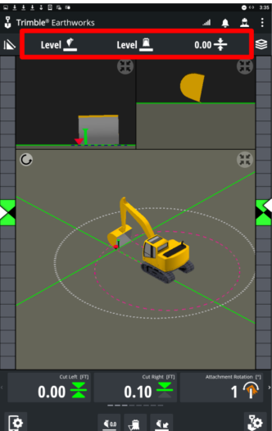
2. There are a few ways to adjust the angle for the Slopes
a. Drag the green line up or down to increase or decrease the value.
b. Use the Up/Down arrows to increase or decrease the value.
c. Manually enter the value with the on screen keypad by touching the numeral box.
d. You can flip the offset from positive to negative with the +/- button.
3. Tap Apply
